**Phase-5 Practice Project: Assisted Practice -**

**4.** **Handling Various Web Elements.**

**Source Code:**

**CheckBoxDemo.java:**

**package** com;

**import** org.openqa.selenium.By;

**import** org.openqa.selenium.WebDriver;

**import** org.openqa.selenium.WebElement;

**import** org.openqa.selenium.chrome.ChromeDriver;

**public** **class** CheckBoxDemo {

**public** **static** **void** main(String[] args) {

System.*setProperty*("webdriver.chrome.driver", "C:\\Users\\Downloads\\chromedriver_win32\\chromedriver.exe");

WebDriver driver= **new** ChromeDriver();

driver.get("https://www.shine.com/registration/");

WebElement checkbox= driver.findElement(By.*id*("id_privacy"));

**if**(checkbox.isSelected())

{

System.***out***.println("Checkbox is Selected by Default");

System.***out***.println("Status: "+checkbox.isSelected());

}

**else** {

System.***out***.println("CheckBox is Not Selected");

}

checkbox.click();

System.***out***.println("Status: "+checkbox.isSelected());

//driver.close();

}

}

**OUTPUT:**

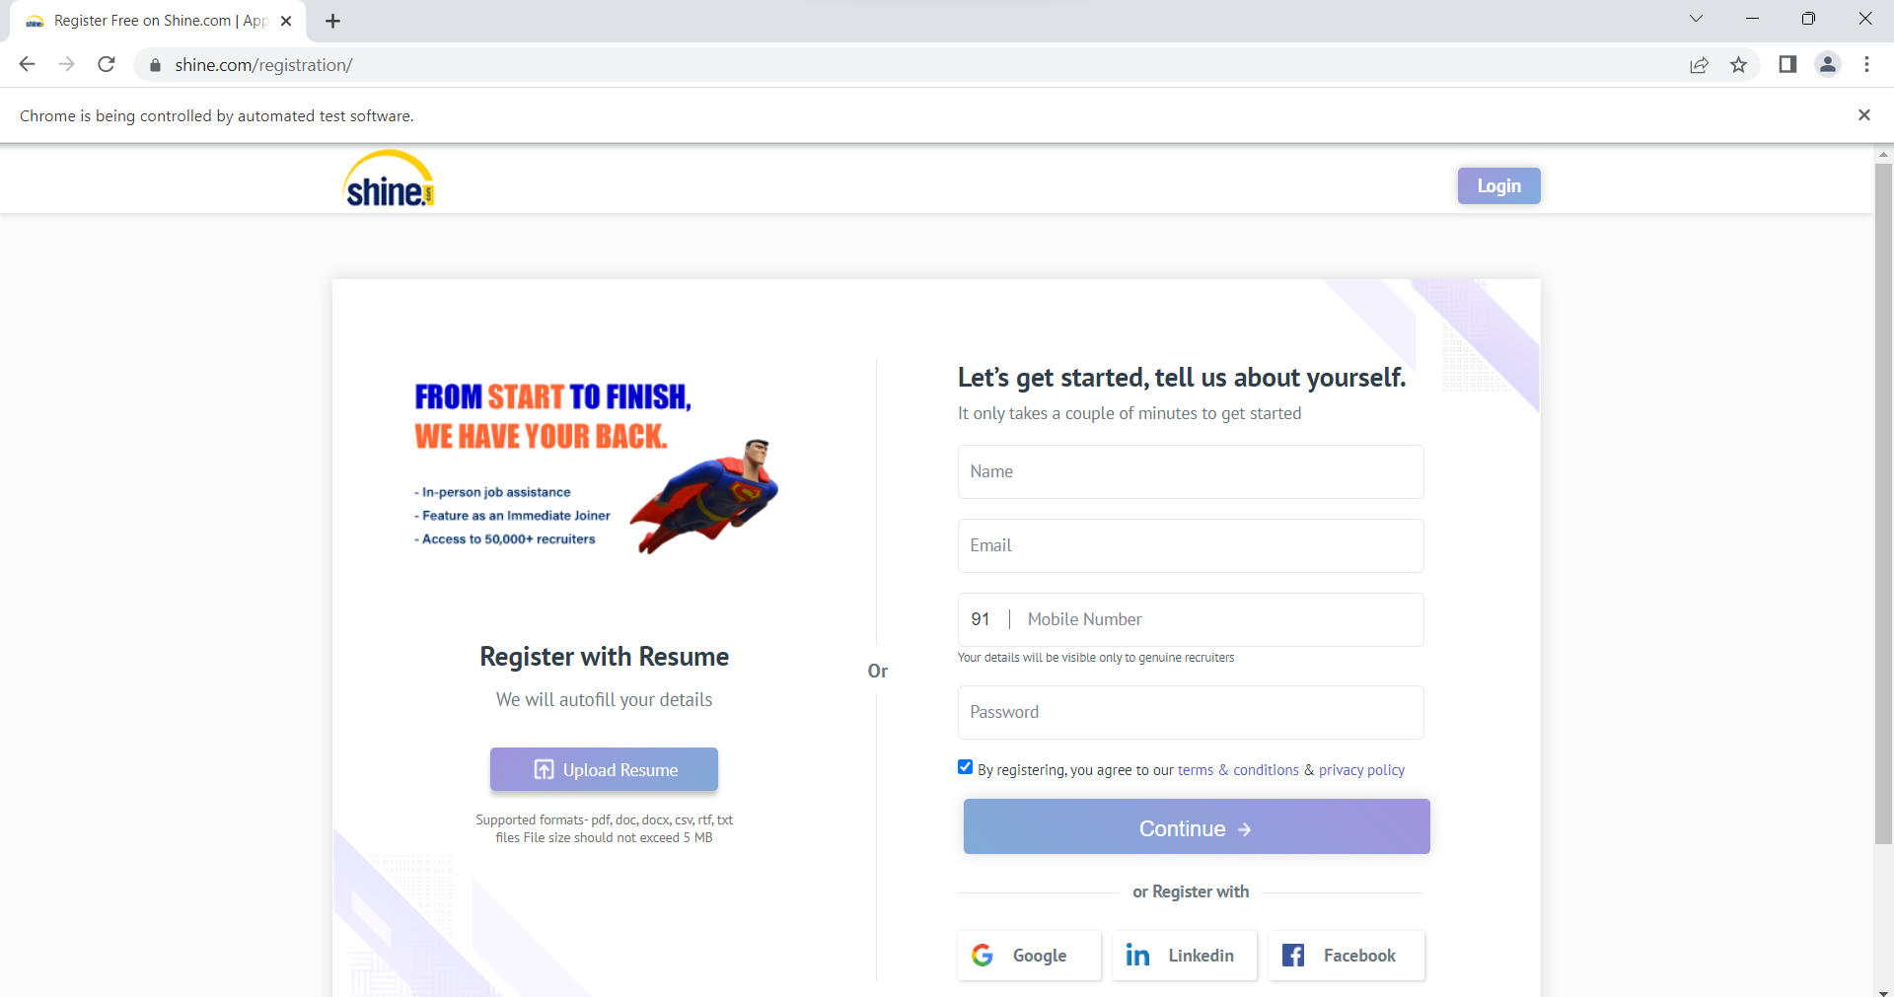

**RegisterForm.java:**

**package** com;

**import** org.openqa.selenium.By;

**import** org.openqa.selenium.WebDriver;

**import** org.openqa.selenium.WebElement;

**import** org.openqa.selenium.chrome.ChromeDriver;

**public** **class** RegisterForm {

**public** **static** **void** main(String[] args) {

System.*setProperty*("webdriver.chrome.driver", "C:\\Users\\Downloads\\chromedriver_win32\\chromedriver.exe");

WebDriver driver= **new** ChromeDriver();

driver.get("https://www.shine.com/registration/");

//name

WebElement name= driver.findElement(By.*id*("id_name"));

name.sendKeys("pavi");

//email

WebElement email= driver.findElement(By.*id*("id_email"));

email.sendKeys("kaviya@gmail.com");

//mobile

WebElement mobile= driver.findElement(By.*id*("id_cell_phone"));

mobile.sendKeys("9876432615");

//password

WebElement password= driver.findElement(By.*id*("id_password"));

password.sendKeys("pavi123");

//button

WebElement register= driver.findElement(By.*cssSelector*("#registerButton"));

register.click();

}

}

**OUTPUT:**

